Request no.:  (filled by Order Office) |  |  |  |  |  |  |  |  |  |  |  |  |  |  |  |  |  |  |  |  |  |  |  |  |  |  | : +34 93 573 11 84
Project no.: |  |  |  |  |  |  |  |  |  |  |  |  |  |  |  |  |  |  |  | Qty. |  |  | 3 |  |  |  | Email:  s.difranca@assaabloy.com
Project name: |  |  |  |  | Kaufland Bulgaria |  |  |  |  |  |  |  |  |  |  |  |  |  |  |  |  |  |  |  |  |  | ll.salvatella@assaabloy.com
NL | 2000 |  |  |  |  |  |  |  |  |  | 2500 |  |  |  |  |  |  |  | 3000 |  |  |  |  |  |  |  |  | 3500 |  |  |  | 4000 |  |  | 4500
LH | 600 |  |  |  |  |  | 700 |  |  |  | 600 |  |  |  | 700 |  |  |  | 600 |  |  |  |  | 700 |  |  |  | 800 |  |  |  | 900 |  |  | 900
NW |  |  |  | 1750 |  |  |  |  | 2000 |  |  |  |  |  |  | 2200 |  |  |  |  |  | 2250
Off standard |  | NL |  |  |  |  |  |  |  | LH |  |  |  |  |  |  | NW
 |  |  |  |  |  |  |  |  |  | Swingdock |  |  |  |  |  |  |  |  |  |  |  |  |  |  | Teledock
Frame
 |  |  |  |  |  |  |  |  |  | ■ T |  |  | H |  |  | W |  | Autodock |  |  |  |  |  |  | ■ T |  |  |  |  | H |  |  |  | W
 |  |  |  |  |  |  |  |  |  | P |  |  | F |  |  | Box |  |  |  |  |  |  |  |  | F |  |  |  |  | Box |  |  |  | Autodock
Load capacity:
60 kN |  |  |  |  |  |  |  |  |  | ■ |  |  |  |  |  |  |  |  |  |  |  |  |  |  |  |  |  |  |  |  | ■
kN
Lip model
steel |  |  |  |  |  |  |  |  |  | ■ |  |  |  |  |  |  |  |  |  |  |  |  |  |  |  |  |  |  |  |  | ■
aluminium
Lip length
400 |  |  |  |  |  |  |  |  |  | ■ |  |  |  |  |  |  |  |  |  |  |  |  |  |  | 500 |  |  |  |  |  | ■
500 |  |  |  |  |  |  |  |  |  |  |  |  |  |  |  |  |  |  |  |  |  |  |  |  | 1000
Type of lip
standard |  |  |  |  |  |  |  |  |  | ■ |  |  |  |  |  |  |  |  |  |  |  |  |  |  | standard |  |  |  |  |  | ■
lip tapered |  |  |  |  |  |  |  |  |  |  |  |  |  |  |  |  |  |  |  |  |  |  |  |  | lip tapered |  |  |  |  |  | 100 |  |  |  |  |  | 150
fold down segments, steel lip only |  |  |  |  |  |  |  |  |  |  |  |  |  |  |  |  |  |  |  |  |  |  |  |  | toe guards |  |  |  |  |  | 2
Lip options [steel]
bevelled |  |  | 40 mm |  |  |  |  |  |  | ■ |  |  |  |  |  |  |  |  |  |  |  |  |  |  |  |  |  |  |  |  | ■
 |  |  | 100 mm
bent |  |  |  |  |  |  |  |  |  | ■ |  |  |  |  |  |  |  |  |  |  |  |  |  |  |  |  |  |  |  |  | -
straight |  |  |  |  |  |  |  |  |  |  |  |  |  |  |  |  |  |  |  |  |  |  |  |  |  |  |  |  |  |  | -
Surface dock leveller
RAL 5010 |  |  |  |  |  |  |  |  |  | ■ |  |  |  |  |  |  |  |  |  |  |  |  |  |  |  |  |  |  |  |  | ■
RAL
hot galvanized
EPDM Seal
without |  |  |  |  |  |  |  |  |  | ■ |  |  |  |  |  |  |  |  |  |  |  |  |  |  |  |  |  |  |  |  | ■
with
Control unit
950 L SD |  |  |  |  |  |  |  |  |  |  |  |  |  |  |  |  |  |  |  |  |  |  |  |  | 950 LA TD
950 LA SD  950 DL SD |  |  |  |  |  |  |  |  |  |  |  |  |  |  |  |  |  |  |  |  |  |  |  |  | 950 DLA TD
950 DLA SD |  |  |  |  |  |  |  |  |  |  |  |  |  |  |  |  |  |  |  |  |  |  |  |  | 950 LSA
950 LS SD |  |  |  |  |  |  |  |  |  |  |  |  |  |  |  |  |  |  |  |  |  |  |  |  | 950 DLSA
950 LSA SD
950 DLS SD
950 DLSA SD
Control options
emergency stop push button
 |  |  |  |  |  |  |  |  |  |  |  |  |  |  |  |  |  |  |  |  |  |  |  |  | automatic retraction

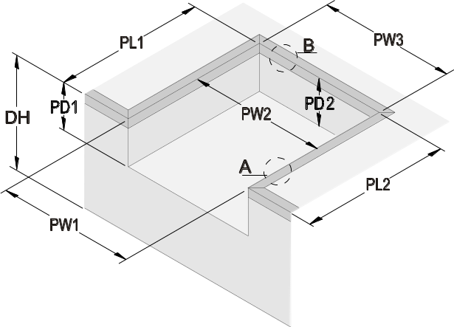 |  |  |  |  |  |  | Pit dimensions (plain steel dimensions)
 |  |  |  |  |  |  | PL1 |  |  |  | = |  |  |  |  |  |  | [mm] pit length left
 |  |  |  |  |  |  | PL2 |  |  |  | = |  |  |  |  |  |  | [mm] pit length right
 |  |  |  |  |  |  | PW1 |  |  |  | = |  |  |  |  |  |  | [mm] pit width front
 |  |  |  |  |  |  | PW2 |  |  |  | = |  |  |  |  |  |  | [mm] pit width middle
 |  |  |  |  |  |  | PW3 |  |  |  | = |  |  |  |  |  |  | [mm] pit width back
 |  |  |  |  |  |  | PD1 |  |  |  | = |  |  |  |  |  |  | [mm] pit depth front
 |  |  |  |  |  |  | PD2 |  |  |  | = |  |  |  |  |  |  | [mm] pit depth back
 |  |  |  |  |  |  | DH |  |  |  | = |  |  |  |  |  |  | [mm] dock height
 |  |  |  |  | 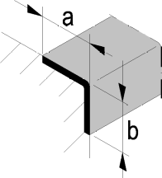 |  |  |  |  |  |  |  |  |  |  |  |  | existing steel dimensions
 |  |  |  |  |  |  |  |  |  |  |  |  |  |  |  |  | side  A | a |  | = |  |  |  |  | [mm]
 |  |  |  |  |  |  |  |  |  |  |  |  |  |  |  |  |  | b |  | = |  |  |  |  | [mm]
back
B
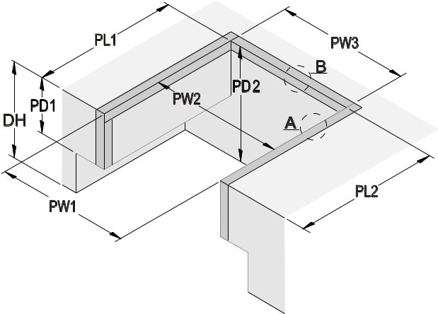 |  |  |  |  | 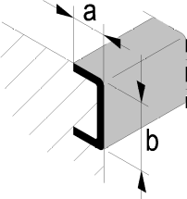 |  |  |  |  |  |  |  |  |  |  |  |  | existing steel dimensions
 |  |  |  |  |  |  |  |  |  |  |  |  |  |  |  |  | side  A | a |  | = |  |  |  |  | [mm]
 |  |  |  |  |  |  |  |  |  |  |  |  |  |  |  |  |  | b |  | = |  |  |  |  | [mm]
back
B
 |  |  |  |  | Other pit design:
Please sketch other kind of profile with dimensions!
NW AutoDOCK
 |  | 3300 |  | 3500 |  |  |  |  |  | 3600
Frame AutoDOCK
 |  | RAL 5010 |  |  |  | hot galvanized |  |  |  |  |  |  |  |  |  | RAL
Angle | 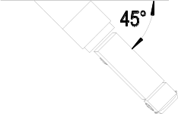 |  |  |  |  |  |  |  | 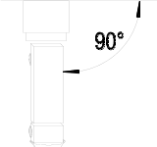 |  |  |  |  |  |  |  |  |  | 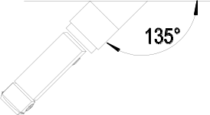
 |  | 90° |  | 45° |  |  |  |  |  | 135° |  |  |  |  | °
Remarks: Customer requests 6030 Combidock in 2000 x 4000 mm with "one piece platform"

